Keeping an Accurate Office 365 Tenant Directory is Important

Posted on [**November 25, 2020**](https://office365itpros.com/2020/11/25/keeping-accurate-office-365-tenant-directory/) by [**Tony Redmond**](https://office365itpros.com/author/thoughtsofanidlemind/)

Cherish Your Azure AD Data

Every Office 365 tenant uses Azure Active Directory to store information about the tenant configuration, accounts, and groups. Maintaining accurate user account information is important. Whether data comes from an external source like a HR feed or is maintained manually, people depend on directory information to find others, or even understand how the organization works. If the data in your directory is inaccurate, some features won’t work properly or at all. For example:

* The Office 365 people card (which makes the [**Intelligent Search**](https://petri.com/microsoft-365-substrate-intelligent-search) of Microsoft 365 rather stupid)
* Teams organization tab (Figure 1) because reporting relationships won’t be correct.
* [**Dynamic distribution lists**](https://office365itpros.com/2020/11/23/exchange-online-dynamic-distribution-lists/) and dynamic Microsoft 365 groups because the right people won’t be found by the queries underpinning dynamic lists and groups.

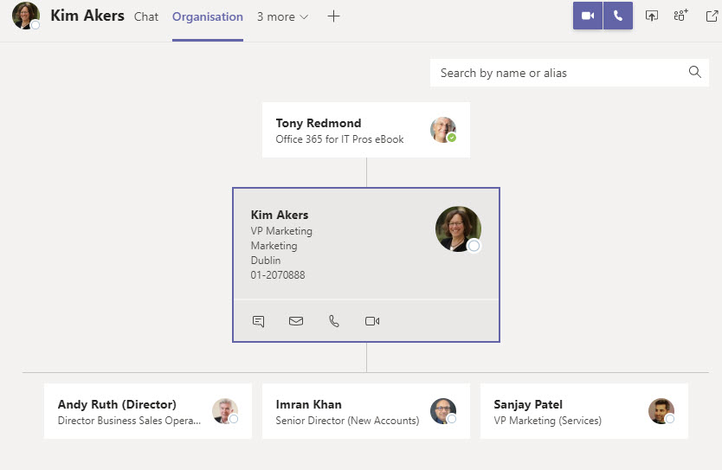Figure 1: The Teams organization tab depends on accurate directory information

It’s always been important to maintain an accurate directory. Perhaps it was less so in the on-premises world where fewer application features are built with an expectation that directory data is accurate, but it’s obvious that Microsoft 365 just works better with a solid directory.

Setting Goals for a Healthy Directory

You can invest in a product like **[Hyperfish](https://www.hyperfish.com/" \t "_blank)** to help analyze and maintain your Azure AD data, but before you rush into acquiring a sticking plaster to cure your directory woes, it’s a good idea to set down some threshold for directory quality. For example, you could say that your baseline measurement for a healthy directory is that all the properties displayed on the people card should be fully populated for every user account. Separate guidelines might be defined for guest accounts and groups.

Figure 2 shows a customized people card. Being able to [**customize the people card using Microsoft Graph commands**](https://office365itpros.com/2020/08/05/customizing-office-365-profile-card-graph-explorer/) allows tenants to expose the information they consider essential in the card, and it’s important to consider customization when setting your threshold.

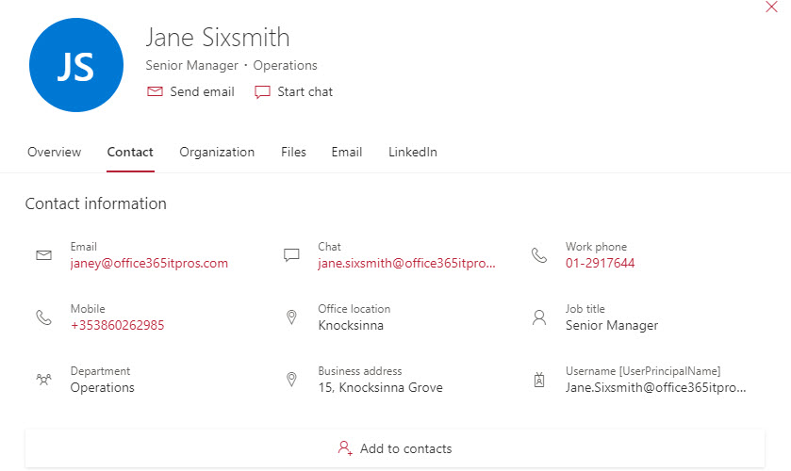Figure 2: Directory information is shown in the Office 365 people card

Checking Azure AD with PowerShell

Setting an aspirational goal is nice, achieving that goal is even better. We need to understand how healthy our directory is in terms of missing properties that show up in the people card. Fortunately, this is easy to create a PowerShell script to:

* Find mailbox-enabled user accounts in Azure AD.
* Check accounts for missing properties (like not having values in the *Office* or *Title* properties).
* Report what needs to be done in terms of account updates.

I’ve written a quick and dirty script which you can [**download from GitHub**](https://github.com/12Knocksinna/Office365itpros/blob/master/FindPotentialDirectoryProblems.PS1). It uses the *Get-User* cmdlet from the [**Exchange Online Management module**](https://office365itpros.com/2020/09/22/microsoft-updates-exchange-online-management-module/) to fetch account information. *Get-AzureADUser* from the AzureAD module could also be used, but it’s easier to filter out mailbox-enabled accounts with *Get-User*, which exposes the Azure AD properties we want to check. Remember that you’ll need to modify the script to suit the circumstances in your organization. For instance, if you place particular importance on a specific property, you might want to amend the script to include that property in the checks.

Figure 3 shows how the script reports the problems it finds with missing properties in user accounts. The results shown here are from a small test tenant so it’s unsurprising to discover that so many accounts have missing properties. It’s reasonable to expect better results in a production tenant.

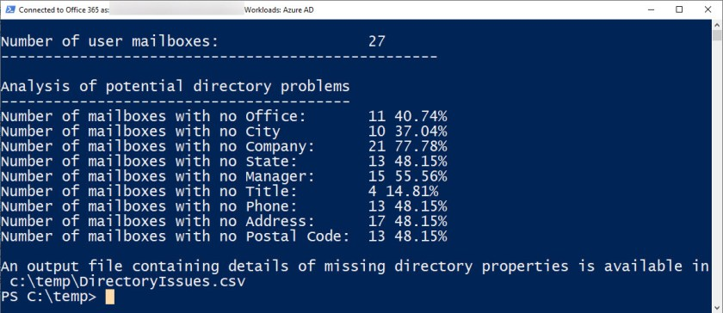Figure 3: PowerShell finds some missing properties in Azure AD user accounts

To make it easy for administrators to track down and fix missing properties. a CSV file is also generated with details of the accounts which need adjustment (Figure 4).

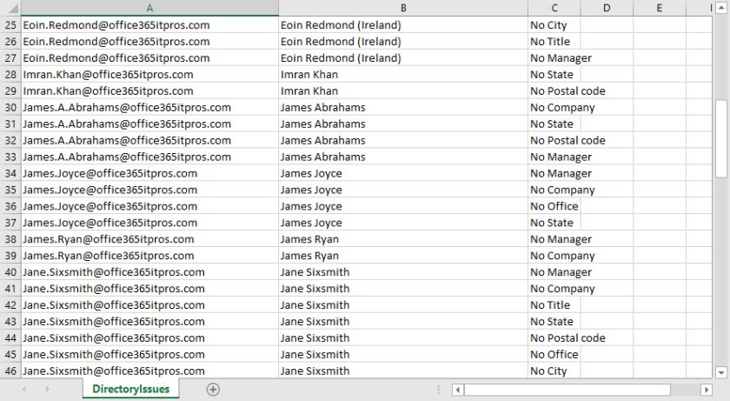Figure 4: Viewing the CSV file of missing directory properties